**Internal Policy Tracking Understanding**

* **JIRA ID**: 31384
* **Description:** User now has the facility to select and work upon the policies that are created internally in the RMA Application using an Internal Policy System. Internal Policy System in actual contains the policies that are created via Maintenance🡪Policy Tracking
* **Creation of RMA Internal Policy System:**
* Navigate to Utilities🡪Managers🡪Policy Setup🡪Policy System Setup🡪Click on New button🡪 Policy System Web Settings window will open. Please refer screenshot below:

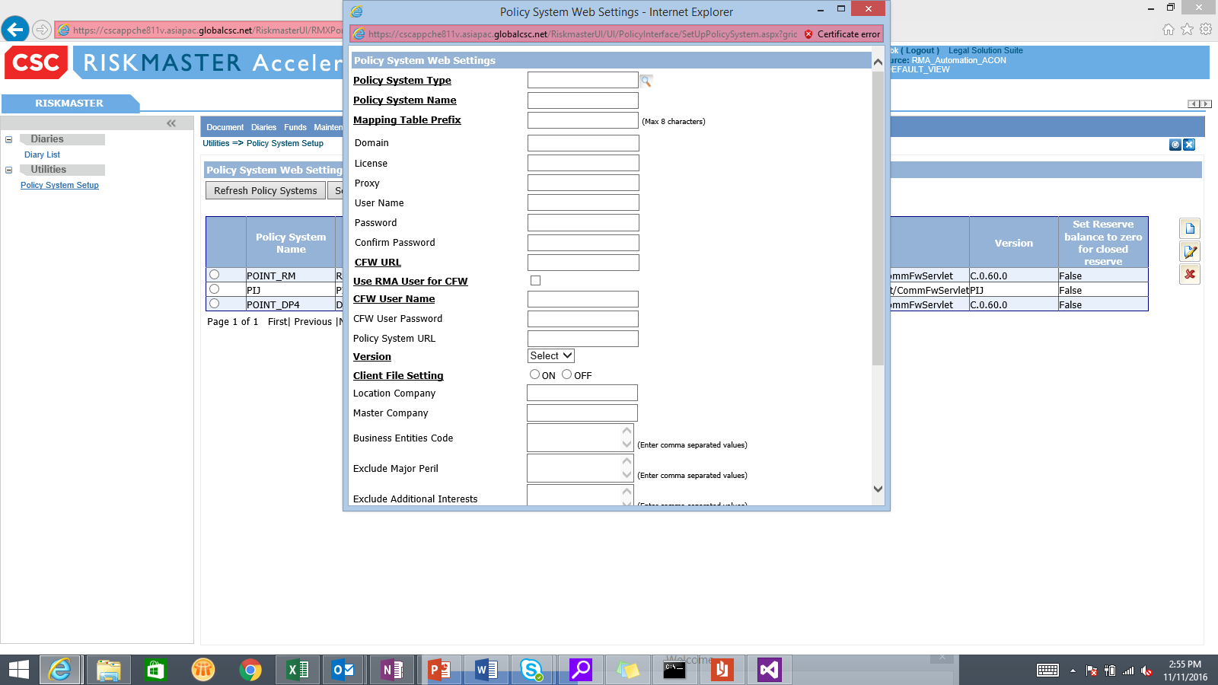

* Click on Policy System Type search button🡪On the opened code selection window select “RMA INTERNAL POLICY”. Please refer the below screenshot

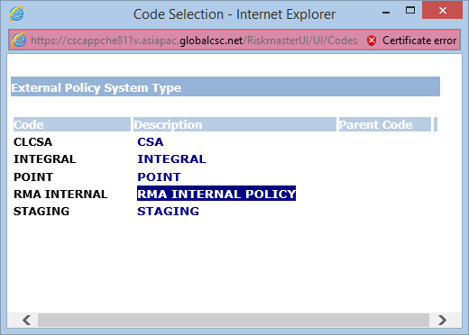

* Select intended Policy System Name. Here “RMA_Internal” was selected🡪Click on OK button🡪At present “An error has occurred while saving policy system data.” is displayed on saving the newly created policy system. Hence further cannot be evaluated
* **General System Settings for RMA Internal Policy System:**
  + Navigate to Utilities🡪System Parameters🡪General System Parameter Setup🡪Policy Interface Settings tab🡪User needs to check “Allow Internal Policy Search” check box to use the RMA Internal Policy System. Please refer the screenshot below:

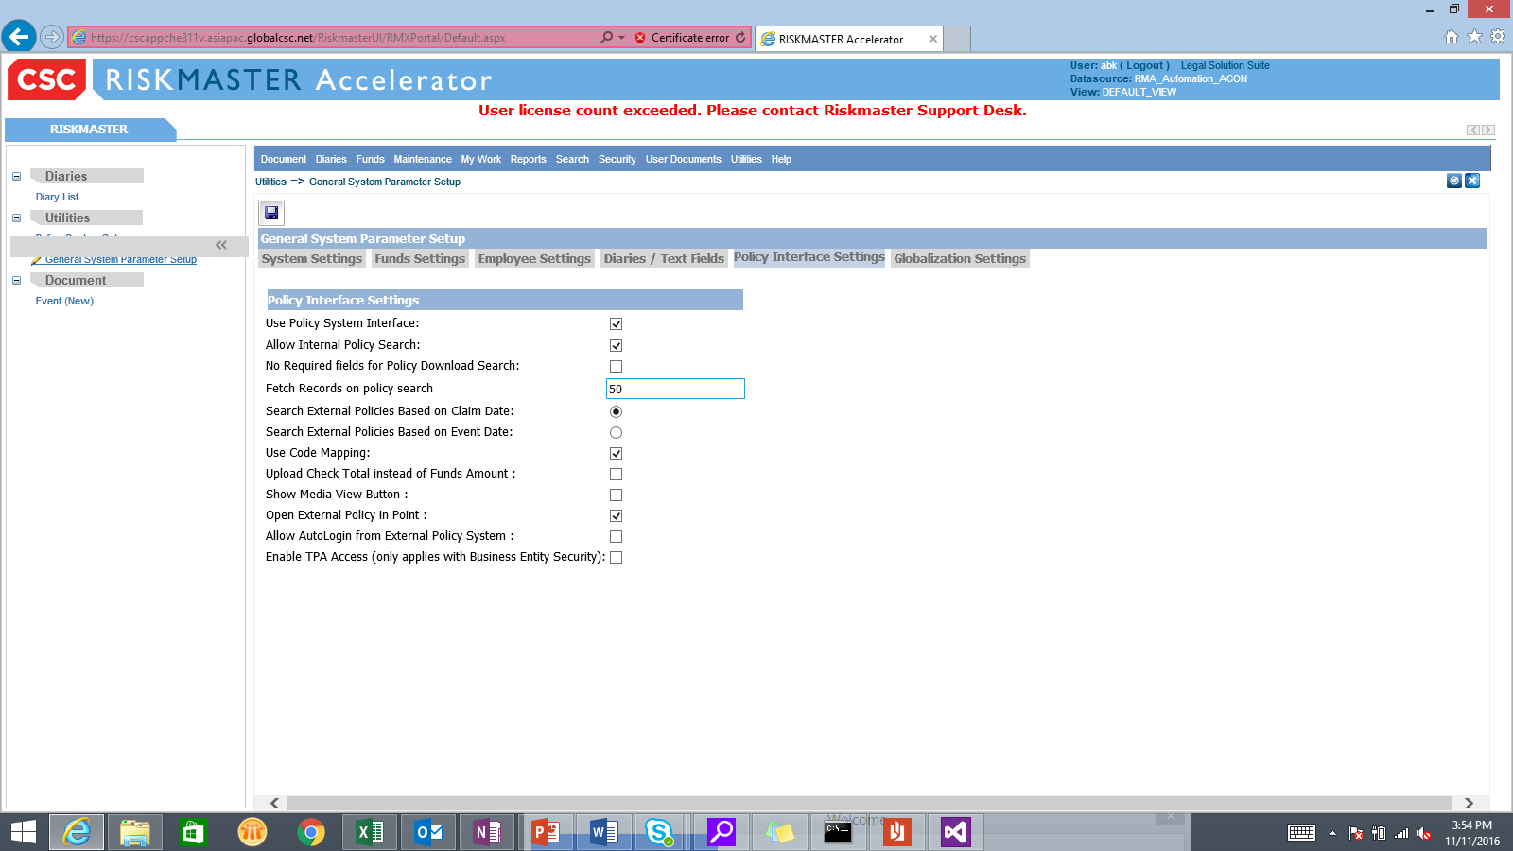

* + If user checks “Allow Internal Policy Search” and “Use Policy System Interface” simultaneously then the following message pop-up is displayed:

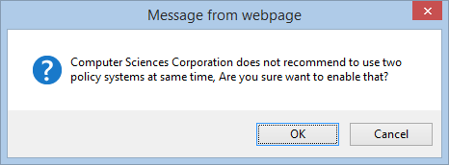

* **Selection of an Internal Policy for a Claim:**
  + Once all the settings are done, navigate to new general claim creation screen🡪Please enter the claim and event date🡪Now the first image associated with Policy Name textbox is of Standard Policy Search. Please refer below screen shot:

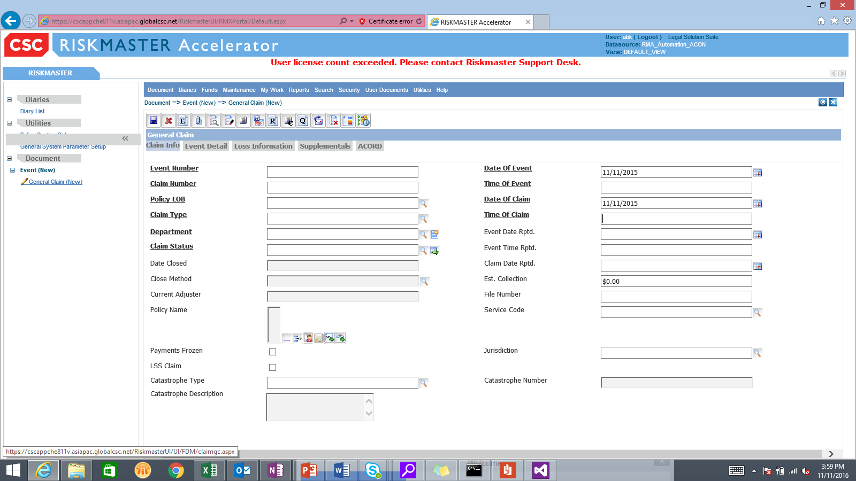

* + On clicking standard policy search image icon standard policy search page will open. Please refer the below screenshot:

